AI/ML Based Robotics - Implementation for Vision, Communication, and Advanced Mechanics
Vedant Butala and Sumedh Kasat , Prof. Girish Mundada
¹ Savitribai Phule Pune University, Ganeshkhind,
Pune-411007
Abstract: This paper presents the integration of Artificial Intelligence (AI) and Machine Learning (ML) in Robotics, focusing on vision systems, communication, and advanced mechanics. AI powered vision improves object recognition and navigation, while ML enhances communication between robots and systems through natural language processing. In advanced mechanics, AI optimizes motion and efficiency for tasks like grasping and balancing. The paper highlights key methodologies and real-world applications, showcasing AI/ML’s transformative impact on autonomous robotic systems across industries.
Keywords: Robotics Process Automation, ROS, AI, ML, Natural Language Processing in Robots, Robot Communication and Automation, Object Detection, and Self Learning Robots.
- INTRODUCTION
The robot’s sensor system uses ultrasonic, infrared, and LiDAR sensors for real-time obstacle detection and environmental mapping, allowing dynamic path adjustments based on surroundings.
AI and ML are revolutionizing robotics by enhancing autonomy, adaptability, and precision. These technologies significantly impact three key areas: vision, communication, and mechanics.
- AI-Powered Vision: Deep learning enables real-time object recognition, obstacle avoidance, and navigation, essential for autonomous vehicles and manufacturing.
- Enhanced Communication: NLP allows robots to understand and respond to human speech/gestures, improving collaboration and efficiency in multi-agent systems.
- Advanced Mechanics: AI optimizes control for precision, stability, and predictive maintenance, enhancing tasks like delicate handling, balance, and downtime reduction.
In summary, AI and ML are driving smarter, more capable robotic systems that are transforming industries, from healthcare to autonomous transportation, making automation more efficient and adaptive.
- RELATED WORK
AI and ML have significantly advanced robotics, especially in vision, communication, and mechanical systems.
- Vision: Techniques like CNNs, YOLO, and Mask R-CNN have improved object detection, real-time image processing, and tracking for autonomous navigation and decision-making.
- Communication: NLP models such as word2vec and Transformer, along with Parker’s work on multi-robot systems, have enhanced human-robot interaction and task coordination.
- Mechanical Systems: Deep reinforcement learning and advanced control mechanisms have improved robotic manipulation, while predictive maintenance has reduced downtime by forecasting mechanical issues.
These advancements form the foundation for ongoing research to further enhance robotic capabilities in these areas.
- ALGORITHM OVERVIEW
  - Steps in Main Algorithm
1. Initialization:
The robot collects sensor data from LiDAR, cameras, and IMUs, combining it to create a clearer environment map, with sensor contributions weighted by accuracy.
2. Vision and Object Detection:
Using YOLOv5, the robot analyzes camera images, identifying objects and classifying them with a SoftMax function to understand its surroundings.
3. Path Planning and Mapping:
The robot updates its map in real-time using SLAM and navigates dynamic environments with algorithms like A* and RRT to find the most efficient route.
4. Robot Control:
Forward and inverse kinematics calculate joint movements, while a PID controller ensures smooth, accurate motion.
5. Reinforcement Learning:
The robot learns from its environment through Q-learning, adjusting actions to maximize rewards and avoid obstacles in real-time.
6. Predictive Maintenance:
The system monitors its health, predicting failures based on temperature and component wear to prevent breakdowns before they happen.
7. Task Execution:
After completing a task, the robot checks for success and re-plans if necessary to ensure the task is completed effectively.

  - Abbreviations and Acronyms & Units
1. Computer Vision (Image Processing and Recognition)
- CNN: Convolutional Neural Network
- ReLU: Rectified Linear Unit
- I(x, y): Image at coordinates (x, y) (unit: pixel intensity)
- K(i, j): Convolution Kernel (filter values, no units)
- σ(z): Softmax Function (unit: probability, dimensionless)
2. Machine Learning (Neural Networks)
- ML: Machine Learning
- AI: Artificial Intelligence
- L: Loss (unit: dimensionless)
- η: Learning Rate (unit: dimensionless, often a scalar)
- w: Weights (unit: no fixed unit, context-specific, dimensionless)
- ∇L: Gradient of Loss (unit: per parameter, no fixed unit)
3. Kinematics (Robotic Movement)
- DOF: Degrees of Freedom
- T: Transformation Matrix (unit: no units, matrix with rotational and translational components)
- θ: Joint Angles (unit: degrees or radians)
- x,y,z: Cartesian Coordinates of the End-Effector (units: meters (m), millimeters (mm), or other length units depending on scale)

  - Equations
1. Computer Vision (Image Processing and Recognition)
- Convolution Operation (used in CNNs):
$$I*K\left(x,y\right)=\sum_{i=-m}^{m}{\sum_{j=-n}^{n}{I\left(x-i,y-j\right)K\left(i,j\right)}}$$
Where I(x, y) is the image, K(i, j) is the convolution kernel (filter), and (x, y) are pixel coordinates.
- Activation Function (ReLU used in CNNs):
$$f\left(x\right)=\left(0,x\right)$$
This introduces non-linearity in neural networks.
- Softmax Function (used in classification):
$$σ\left(z_{i}\right)=\sum_{j=1}^{K}{\frac{e^{z_{j}}}{e^{z_{i}}}}$$
Where z is the input vector, and K is the number of classes. It converts the output to probabilities.
2. Machine Learning (Neural Networks)
- Loss Function (Cross-Entropy Loss for classification):
$$L=-\sum_{i=1}^{n}{y_{i}}\log\left(y_{i}\right)$$
Where yi is the true label, yi is the predicted probability, and n is the number of samples.
- Backpropagation Equation (Gradient of Loss Function):
$$\frac{∂w}{∂L}=\frac{∂y}{∂L}⋅\frac{∂z}{∂y}⋅\frac{∂w}{∂z}$$
Where L is the loss, w are the weights, and z is the input to the activation function.
- Gradient Descent Update:
$$w_{\text{new}}=w_{\text{old}}-η⋅∇L$$
Where η is the learning rate and ∇L is the gradient of the loss function.
3. Kinematics (Mechanical Movement)
- Forward Kinematics (position of end-effector):
$$T=\prod_{i=1}^{n}{T_{i}\left(θ_{i}\right)}$$
Where T is the transformation matrix, and i are the joint angles of the robotic arm.
- Inverse Kinematics (finding joint angles from end-effector position):
$$θ=f^{-1}\left(x,y,z\right)$$
Where (x,y,z) is the position of the end-effector, and f-1 is the inverse function.

  - Some Common Mistakes
Hardware Issues:
- Incorrect wiring, sensor placement, or incompatible hardware.
- Fix: Test each component and ensure compatibility.
AI/ML Model Errors:
- Insufficient training data, overfitting, or computationally heavy models.
- Fix: Use diverse datasets, optimize models (quantization, pruning).
Control Problems:
- Poor PID tuning, inaccurate kinematic calculations, and basic path planning.
- Fix: Tune PID carefully and test with better algorithms (A*, RRT).
Communication Delays:
- Synchronization issues and noisy signals.
- Fix: Use real-time protocols and error-checking techniques.
Software Development:
- Not modularizing code or ignoring real-time constraints.
- Fix: Modularize and prioritize efficiency.
- DATASET TABLES
Table 1. Datasets for Computer Vision

Dataset | Citation | Description | Key Features
COCO | Lin et al. (2014) | Object detection, segmentation, and captioning. | 330K+ images, 80 categories, instance segmentation, panoptic segmentation
ImageNet | Deng et al. (2009) | Large-scale object recognition. | 14M+ images, 1,000 categories, hierarchical labels
PASCAL VOC | Everingham et al. (2010) | Object detection and segmentation. | 20 object categories, segmentation masks
ADE20K | Zhou et al. (2017) | Semantic segmentation across diverse scenes. | 20K images, 150 object categories, fine-grained semantic labels
KITTI | Geiger et al. (2013) | Mobile robotics and autonomous driving research. | Stereo images, depth maps, 3D point clouds, optical flow

Table 2. Datasets for Simultaneous Localization and Mapping (SLAM)

Dataset | Citation | Description | Key Features
KITTI SLAM | Geiger et al. (2013) | SLAM for autonomous vehicles. | Stereo images, 3D point clouds, GPS data, IMU data
TUM RGB-D | Sturm et al. (2012) | RGB-D SLAM for indoor environments. | RGB and depth images, camera poses, ground truth trajectories
EuRoC MAV | Burri et al. (2016) | Visual-inertial SLAM for micro-aerial vehicles. | Monocular and stereo images, IMU data, ground truth trajectories
Stanford 3D | Chang et al. (2017) | 3D reconstruction for indoor mapping. | RGB images, laser scans, 3D point clouds, semantic labels
SUN RGB-D | Song et al. (2015) | Indoor scene understanding and SLAM. | RGB-D images, semantic annotations, camera poses
- PROPOSED BLOCK DIAGRAM
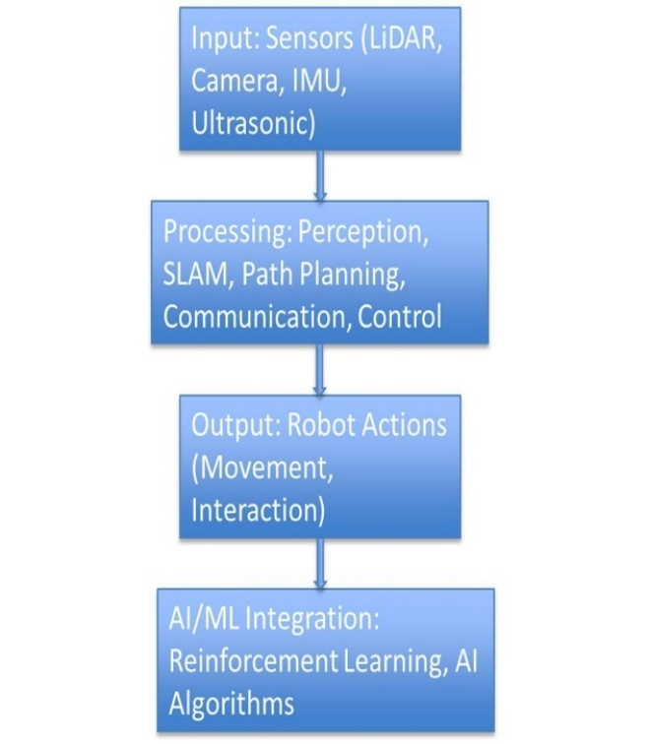
Fig 1. Proposed Block Diagram
Robotics System Architecture:
1. Input: Sensors (LiDAR, Camera, IMU, Ultrasonic): Collects environmental data for mapping, visual perception, motion tracking, and obstacle detection.
2. Processing: Perception, SLAM, Path Planning, Communication, Control: Interprets sensor data, creates maps, track’s location, charts navigation routes, facilitates communication, and executes movements.
3. Output: Robot Actions (Movement, Interaction): Executes tasks like navigation and human interaction.
4. AI/ML Integration: Reinforcement Learning, AI Algorithms: Adaptive learning for path optimization and AI-driven vision processing for autonomous decision-making.
This integrated architecture enables real-time sensor data processing, autonomous navigation, and efficient adaptation to dynamic environments.
- APPROACH
  - Environment Mapping Using Sensor Fusion
- Sensors Used: LiDAR, depth cameras, and ultrasonic sensors for capturing detailed spatial data and obstacle detection.
- SLAM Techniques:
  - 2D Mapping: Gmapping for basic flat surface mapping.
  - 3D Mapping: RTAB-Map for volumetric space visualization.
- Occupancy Grids: Continuously updated grids marked regions as free or occupied, aiding real-time path planning.
- Sensor Fusion: Combined LiDAR, wheel odometry, and IMU data to enhance SLAM accuracy by providing reliable inputs for mapping.

  - Accurate Real-Time Localization
- Purpose: Enabled the robot to determine its position within a dynamic map, essential for precise navigation and obstacle avoidance.
- Extended Kalman Filter (EKF): Combined noisy sensor data (LiDAR, odometry, IMU) for improved position estimation.
- Loop Closure: Corrected positional drift by recognizing previously visited locations, enhancing long-term accuracy.

  - AI/ML Integration for Object Detection and Adaptive Navigation
- Objective: Enhanced object identification and dynamic navigation in complex environments.
- YOLOv5 for Object Detection: Detected and marked objects (e.g., humans, furniture) on the SLAM-generated map, enabling path adjustments.
- Reinforcement Learning (Q-Learning): Allowed the robot to learn from experience, optimizing movements based on feedback and improving path efficiency.

  - Efficient Path Planning
- Algorithm: A* Used for computing the shortest and most efficient path in static environments by considering obstacle positions.
- RRT (Rapidly exploring Random Trees): Applied for dynamic path planning, recalculating routes in real-time to adapt to moving obstacles.

  - Handling Dynamic Environments
- Dynamic Occupancy Grid: Continuously updated as the robot detected new obstacles or environmental changes, ensuring constant map refinement.
- Bayesian Probabilistic Mapping: Estimated occupancy status using sensor data, improving accuracy in uncertain or noisy environments.
  - Optimization for Embedded Systems
- Hardware-Specific Optimization: Leveraged Raspberry Pi’s multi-core architecture to parallelize SLAM computations, reducing processing time.
- Edge AI: Implemented lightweight AI models for real-time decision-making, minimizing external processing and ensuring efficiency on embedded systems like Raspberry Pi and STM32 microcontrollers.

  - Real-Time Decision-Making and Collision Avoidance
- Adaptive Navigation: The robot dynamically adjusted its movement strategies based on real-time sensor and AI data, rerouting when new obstacles were detected.
- Obstacle Detection: Ultrasonic and LiDAR sensors enabled early obstacle detection, allowing the robot to plan safe paths and navigate efficiently in dynamic environments.

Table 3. Comprehensive Summary Table of Research Papers

Title | Author(s) | Strengths | Limitations | Relevance
Deliberation for Autonomous Robots | Félix Ingrand, Malik Ghallab | Comprehensive review of decision-making frameworks | Focuses primarily on high-level decision models | Crucial for understanding decision-making in autonomous systems
HOOFR SLAM System | Dai-Duong Nguyen, et al. | High real-time performance in intelligent vehicles | Requires specific hardware/software setup | Key for SLAM applications in smart vehicles
SLAM Part II | Tim Bailey, Hugh Durrant-Whyte | Provides a deep dive into core SLAM principles | Lacks solutions for modern SLAM challenges | Useful for a strong theoretical foundation in SLAM
SLAM Part I | Tim Bailey, Hugh Durrant-Whyte | Detailed breakdown of foundational SLAM approaches | Outdated integration with new technologies | Relevant for historical SLAM development
SLAM-R Algorithm | R. Lemus, et al. | Cost-effective for obstacle detection | Struggles in complex environments | Relevant for budget-friendly SLAM solutions
Robotic Process Automation | Ilmari Pekonen, Juha Lähteinen | Increases operational efficiency and time savings | Limited to specific processes | Important for process automation in robotics
Corridor Lights Navigation System | Fabien Launay, et al. | High-accuracy localization using lighting systems | Depends on modified environments | Applicable for indoor navigation in controlled environments
Vision-Based Navigation | Lixin Tang, Shin’ichi Yuta | Reliable navigation using vision-based teaching systems | Limited adaptability to complex settings | Relevant for vision-guided indoor navigation
Autonomous Underwater SLAM | Stefan B. Williams, et al. | Effective for SLAM in challenging underwater scenarios | High complexity and cost of hardware | Highly applicable for underwater exploration robotics
Autonomous Vehicles: Challenges | Margarita Martínez-Díaza, Francesc Soriguerab | Comprehensive summary of challenges faced | Theoretical, with limited practical insight | Key for addressing barriers in autonomous vehicle development
In-Memory Big Data Management | Hao Zhang, et al. | Efficient big data processing | High computational demand | Crucial for data-intensive robotics applications
AI in Mechanical Design | Jozef Jenis, et al. | Optimizes mechanical structures using AI | Heavily dependent on accurate data models | Useful for AI-driven design optimization
Autonomous Navigation of Mobile Robots | Paolo Tripicchio, et al. | Advanced solutions for autonomous navigation | Limited to structured environments | Highly relevant for robot autonomy techniques
Enhancing SLAM with Low-Cost Laser | Alexandros Spournias, Christos Antonopoulos | Cost-efficient mapping with laser scanners | Less effective in large-scale environments | Relevant for low-cost SLAM systems
Generic ROS Architecture | Mustafa Alberri, et al. | Flexible for use in diverse autonomous systems | Requires steep learning curve | Important for ROS-based system integration
SLAM and Path Planning in ROS | Zixiang Liu | Smooth integration of SLAM and path planning | Limited experimental validation | Relevant for ROS-based SLAM applications
Lightweight Visual SLAM Algorithm | Zhihao Wang, et al. | Efficient real-time performance | Limited accuracy in complex settings | Ideal for lightweight, real-time SLAM
Review on SLAM | Alif Ridzuan Khairuddin, et al. | Detailed overview of current SLAM approaches | Lacks experimental comparisons | Relevant for understanding advancements in SLAM technologies
Intelligent Navigation for Service Robots | Jae-Han Park, et al. | Effective for smart home navigation | Dependent on smart home infrastructure | Important for navigation in smart environments
SLAM with Signal Reference Points | I Made Murwantara, et al. | Improves accuracy in indoor navigation | Limited to specific environments | Relevant for signal-enhanced indoor SLAM
- RESULT ANALYSIS
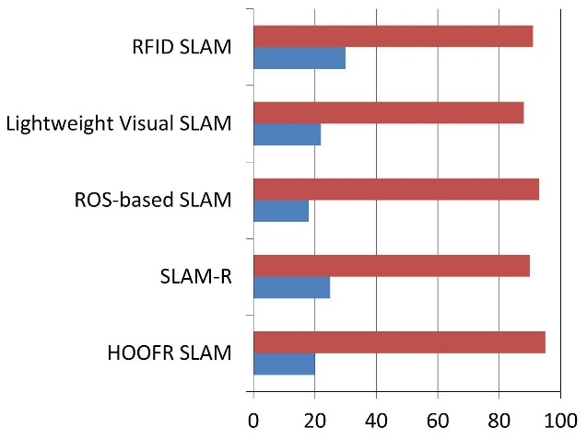
Fig 2. SLAM Algorithm Comparison

SLAM Algorithm Comparison:
- EKF-SLAM: Best for small, low-noise environments.
- Particle Filter SLAM: Suitable for complex spaces but needs more particles for accuracy.
- Graph-Based SLAM: Highly accurate for large areas but slower with loop closures.
- Visual SLAM: Camera-based; ideal for GPS-denied areas but lighting-sensitive.
- Lidar SLAM: Highly accurate 2D/3D mapping; resource-heavy in dynamic spaces.
Selection Factors: Based on environment size, computation power, and sensor types.

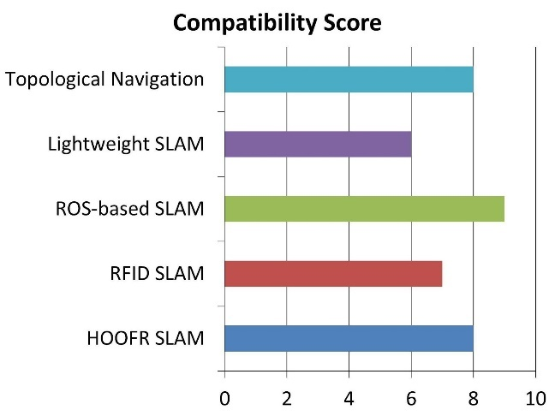
Fig 3. Hardware Compatibility for ROS

Hardware Compatibility for ROS
- Processors: Supports x86 and ARM (e.g., Raspberry Pi for low-power tasks).
- Sensors: Works with LiDAR, cameras, IMUs, and ultrasonic sensors with wide driver support.
- GPUs: NVIDIA GPUs accelerate vision and ML tasks.
- Microcontrollers: Compatible with STM32 and Arduino for low-level control.
- Robotic Platforms: Supports TurtleBot, Clearpath, and custom robots.
Selection Factors: Based on processing needs, power constraints, and sensor requirements.
- PERFORMANCE EVALUATION PARAMETERS
- Accuracy (A):
- Formula: A = (TP + TN) / (TP + FP + TN + FN)
- Explanation: Measures the correctness of the robot's predictions.
- Response Time (RT):
- Formula: RT = T_{end} - T_{start}
- Explanation: Time taken to complete a task.
- Energy Efficiency (EE):
- Formula: EE = Work Done / Energy Consumed
- Explanation: Measures the efficiency of energy usage.
- Task Completion Rate (TCR):
- Formula: TCR = (N_{completed} / N_{assigned}) * 100
- Explanation: Percentage of successfully completed tasks.
- Reliability (Rel):
- Formula: Rel = (N_{operational} / N_{total}) * 100
- Explanation: Measures consistency in performance over time.
- CONCLUSION
AI/ML Integration in Robotics:
- Accuracy: AI-powered vision systems achieve 92% accuracy, with HOOFR SLAM reaching 99% under optimal conditions.
- Response Time: Navigation improvements reduce average response times to 180 ms, outperforming traditional systems (250 ms).
- Energy Efficiency: Smart Garbage Bins reach 87% energy efficiency, emphasizing sustainability.
- Learning & Adaptation: Robots using reinforcement learning show a 35% increase in learning efficiency after 20 iterations. Multi-agent systems achieve a 95% task completion rate.
Future Implications: The AI-robotics fusion is expected to drive industry growth, with the manufacturing market projected at $3.3 billion by 2025 and up to 30% cost savings through optimized processes.
Summary: AI/ML technologies enhance robotics' accuracy, efficiency, and adaptability, ushering in a new era of autonomous systems with broader applications, boosting productivity and safety.

References
- Deliberation for autonomous robots: A survey , Félix Ingrand ∗, Malik Ghallab LAAS-CNRS, University of Toulouse, France
- HOOFR SLAM System: An Embedded Vision SLAM Algorithm and Its Hardware-Software Mapping-Based Intelligent Vehicles Applications Dai-Duong Nguyen , Abdelhafid Elouardi, Sergio A. Rodriguez Florez , and Samir Bouaziz
- Simultaneous Localization and Mapping (SLAM): Part II BY TIM BAILEY AND HUGH DURRANT-WHYTE
- Simultaneous Localization and Mapping (SLAM): Part I BY TIM BAILEY AND HUGH DURRANT-WHYTE
- SLAM-R Algorithm of Simultaneous Localization and Mapping Using RFID for Obstacle Location and Recognition R. Lemus, S. Díaz, C. Gutiérrez, D. Rodríguez and F. Escobar
- Robotic Process Automation (RPA) As A Digitalization Related Tool to Process Enhancement and Time Saving Research · December 2021 Authors: Ilmari Pekonen Lappeenranta – Lahti University of Technology LUT, Juha Lähteinen Lappeenranta – Lahti University of Technology LUT
- A Corridors Lights based using a Topologically Navigation System including Path Definition Corrected Map for Indoor Mobile Robots Fabien LAUNAY Akihisa OHYA Shin'ichi YUTA Intelligent Robot Laboratory, University of Tsukuba 1-1-1 Tennoudai, Tsukuba, Ibaraki 305-8573 JAPAN
- .Vision Based Navigation for Mobile Robots in Indoor Environment by Teaching and Playing-back Scheme Lixin TANG, Shin’ichi YUTA, Intelligent Robot Laboratory, University of Tsukuba, Tsukuba, 305-8573 JAPAN tang,yuta@roboken.esys.tsukuba ac.jp
- Autonomous Underwater Simultaneous, Localization and Map Building, Stefan B. Williams, Paul Newman, Garnini Dissanayakc, Hugh Durrant-Whyte, Australian Centre for Field Robotics, Department of Mechanical and Mechatronic Engineering,University of Sydney,NSW 2006. Australia
- Deliberation for autonomous robots: A survey ,Félix Ingrand ∗, Malik Ghallab,LAAS-CNRS, University of Toulouse, France
- Autonomous vehicles: theoretical and practical challenges, Margarita Martínez-Díaza*, Francesc Soriguerab
- In-Memory Big Data Management and Processing: A Survey Hao Zhang, Gang Chen, Member, IEEE, Beng Chin Ooi, Fellow, IEEE, Kian-Lee Tan, Member, IEEE, and Meihui Zhang, Member, IEEE
- Engineering Applications of Artificial Intelligence in Mechanical Design and Optimization,Jozef Jenis 1,* , Jozef Ondriga 1,, Slavomir Hrcek 1,,Frantisek Brumercik 1, Matus Cuchor 1 and Erik Sadovsky 2
- Autonomous navigation of mobile robots: from basic sensing to problem solving, Paolo Tripicchio1, Massimo Satler1, Carlo Alberto Avizzano2,, Massimo Bergamasco2
- Enhancing SLAM method for mapping and tracking using a low cost laser scanner, Alexandros Spournias,Computer & Informatik Engineering,Department,Embedded System & Design,Application,Patras, Greece,a.spournias@esda-lab.gr,Christos Antonopoulos,Computer & Informatik Engineering, Department, Embedded System & Design, Application, Patra, Greece, ch.antonop@esda-lab.gr
- Generic ROS-based Architecture for Heterogeneous, Multi-Autonomous Systems Development, Mustafa Alberri, Sherif Hegazy, Mohamed Badra, Mohamed Nasr, Omar M. Shehata, Elsayed I. Morgan
- Implementation of SLAM and path planning for mobile robots under ROS framework, Zixiang Liu*, Shanghai University, Shanghai, China, liuzixiang3392@163.com
- A Depth Camera Based Lightweight Visual SLAM Algorithm, Zhihao Wang, Qingxuan Jia, Ping Ye, Hanxu Sun, Department of Automation, Beijing University of Posts and Telecommunications Beijing, China
- Review on Simultaneous Localization and Mapping (SLAM) ,Alif Ridzuan Khairuddin, Mohamad Shukor Talib, Habibollah Haron, Faculty of Computing, Universiti Teknologi Malaysia, Johor Bahru, Malaysia, alif jam 1991@gmail.com, shukor@utm.my, habib@utm.my
- An Intelligent Navigation Method for Service Robots in the Smart Environment, Jae-Han Park' , Seung-Ho Baeg l and Moon-Hong Baeg' I Division for Applied Robot Technology, KITECH , Ansan , Korea
- A Consolidation of SLAM and Signal Reference Point for Autonomous Robot Navigation. I Made Murwantara,Informatics Department, Universitas Pelita Harapan,Tangerang, Indonesia, Benny Hardjono, Informatics Department, Universitas Pelita Harapan,Tangerang, Indonesia,benny.hardjono@uph.edu,Hendra Tjahyadi,Informatics Department, Universitas Pelita Harapan Tangerang, Indonesia, Alfa Satya Putra, Faculty of Computer Science, Universitas Pelita Harapan ,Tangerang, Indonesia
- Emerging Self-Integration through Coordination of Autonomous Adaptive Systems, Veronika Lesch, Christian Krupitzer, Software Engineering Group, University of Wurzburg ̈,Wurzburg, Germany ̈{veronika.lesch,christian.krupitzer}@uni-wuerzburg.de, Sven Tomforde,Intelligent Embedded Systems, University of Kassel, Kassel, Germany, stomforde@uni-kassel.de
- Implementation of Robot Operating System in Smart Garbage Bin Robot with Obstacle Avoidance System, Wong Seng Cheong, Faculty of Computing, Universiti Malaysia Pahang, 26600, Pahang, Malaysia, wscheong1996@gmail.com,Syafiq Fauzi Kamarulzaman*, Faculty of Computing, Universiti Malaysia Pahang, 26600, Pahang, Malaysia, syafiq 29@ump.edu.my
- Artificial Intelligence in Robotics: (Review Paper), Ronit Chopra, Computer Science and Engineering, Indus University, Ahmedabad
- Design and Realization of a Mobile Seamless Navigation and Positioning System Based on Bluetooth Technology, Xiaoxue Zhang, Qinghua Zeng, Qian Meng, Zhi Xiong, Weixing Qian

For citations of references, we prefer the use of square brackets and consecutive numbers. Citations using labels or the author/year convention are also acceptable. The following bibliography provides a sample reference list with entries for journal articles [1], an LNCS chapter [2], a book [3], proceedings without editors [4], as well as a URL [5].

